**How To Set Up Wireless Ad Hoc Internet Connection In Windows 8**

**Procedure**

Step 1: Launch an elevated command prompt under Windows 8 (one with administrator privileges).

Step 2: Run the following command to verify that your network interface supports virtualization:

netsh wlan show drivers

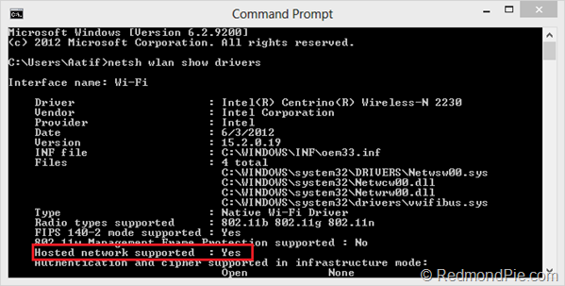

If *Hosted network supported* says Yes, you’re all set. Otherwise, you need to upgrade your hardware, if the software update doesn’t fix it.

Step 3: Now, set up the ad hoc wireless network using this command. Replace the parts in markup tags with your own choices

netsh wlan set hostednetwork mode=allow ssid=<enter_network_name_here> key=<enter_password_here>

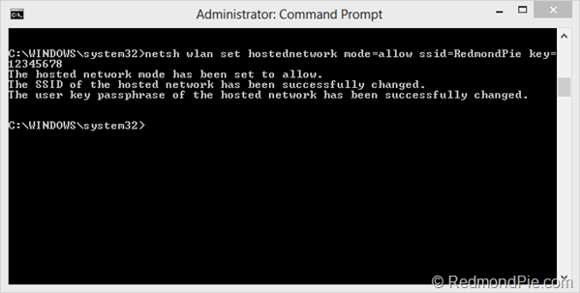

Step 4: Until now, your hosted network has been created. Now, you need to start it. Use the command below:

netsh wlan start hostednetwork

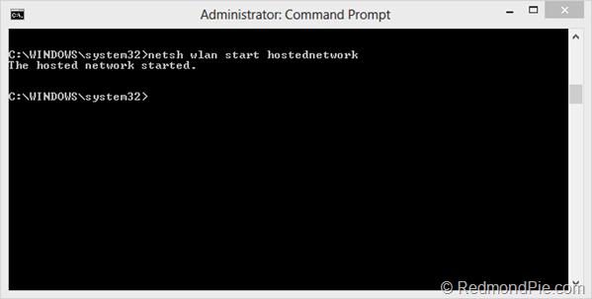

Step 5: You’re all set, with just one thing remaining. If it’s not already enabled, you need to allow Internet Connection Sharing (ICS) for your currently-active internet connection. Simply head over to Network & Sharing Center, and in the properties for the current internet connection, enable ICS. Make sure to select the ad hoc connection under *Home networking connection*.

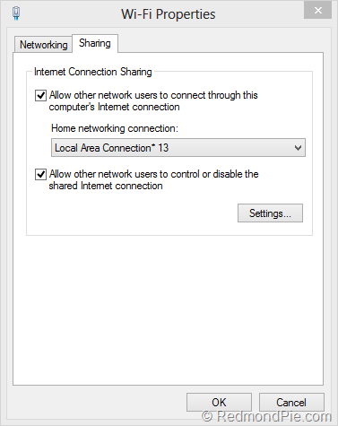

Now you can connect any device to the internet using the ad hoc wireless network with internet connection sharing that you just created on your Windows 8 PC.

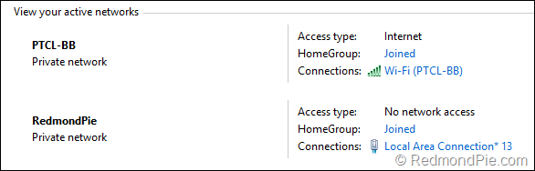

It’s worth noting that this isn’t the only method to create an ad hoc connection. If you don’t want to play around with netsh command, or just need an easier solution, you may simply use a Virtual Router application for Windows, and that should do the trick for you. Google them out, you’ll find various good candidates there.

**How to connect to an ad-hoc WiFi network in Windows 8.1.**

Because the wireless network picker in Windows 8.1 doesn't show ad-hoc networks, connecting must be done by hand.

To see all networks in range, including ad-hoc, run this command in command shell (cmd.exe):

> netsh wlan show networks

*SETUP*

This must be done once per network.

* go to "Network and Sharing Center"
* click "Set up a new connection or network"
* double click "Manually connect to a wireless network"
* enter the SSID of the ad-hoc network (as shown by "netsh wlan show networks") into the "Network name" field
* configure security settings accordingly
* uncheck "Start this connection automatically" (important)
* click "Next", then "Close"

Run this command (important):

> netsh wlan set profileparameter <ssid> connectiontype=ibss

Replace <ssid> with the SSID of your network.

*CONNECT*

After setting up, run this command whenever you want to connect:

> netsh wlan connect <ssid>

Replace <ssid> with the SSID of your network.

Hovering over WiFi icon in system tray will show the name of the network that you are currently connected to, even if it's an ad-hoc network (the network picker will not show it if it's ad-hoc). The name is also visible in "Network and Sharing Center" window.

*DISCONNECT*

To disconnect from the ad-hoc network: connect to a different network, turn off wifi, or run this command:

> netsh wlan disconnect

*CLEANUP*

To remove the network profile from Windows, run this command:

> netsh wlan delete profile <ssid>

Replace <ssid> with the SSID of your network.